**Moore's Law no longer working?**

Already in 2007, Moore himself said that the operation of this law is no longer possible due to fundamental reasons - the atomic nature of matter and the limitation of the speed of light, which does not allow processors to work even faster.

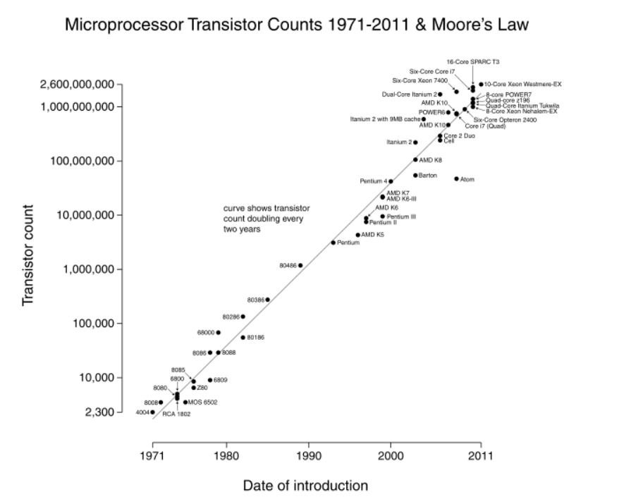

Growth in the number of transistors in the period 1971-2011. Moore's Law

Criticism of Moore's Law appeared almost immediately after its appearance. One of the most vulnerable points of this concept was the point that with an exponential increase in processor capacities, their cost each time decreases by about the same order of magnitude. If in 1969 the cost of creating the first personal computer H316 from Honeywell was more than $ 10 thousand, then by 1971 it should have dropped to $ 5 thousand, and by 1973 - to $ 2.5 thousand. However, in 1975, MOS Technology, Inc. began production of the KIM-1 computer, which cost $ 245.

Not only the financial aspects of this law were constantly criticized, but also the impossibility of transferring it to other areas. In 1983, Scientific American stated in its material that "Moore's law is absolutely impossible to use, not only in industry in the broadest sense of the word, but also in virtually all industries related to computing."